Hotel Reservation Web System
UI DESIGN
1-
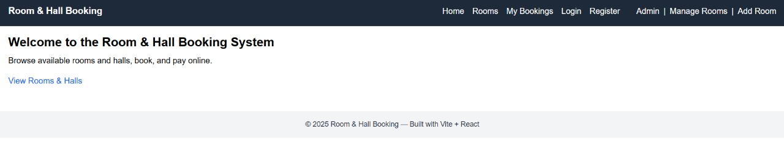

2-
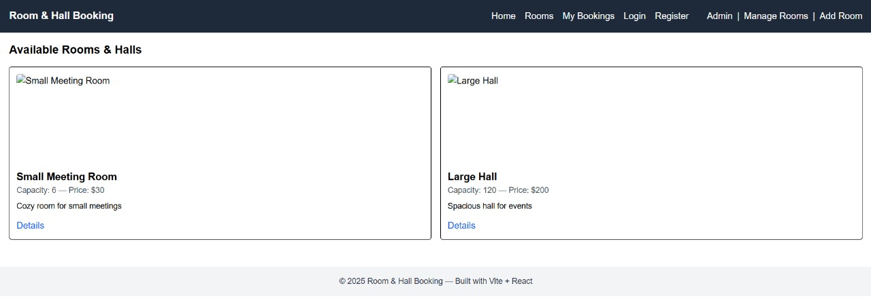
3-

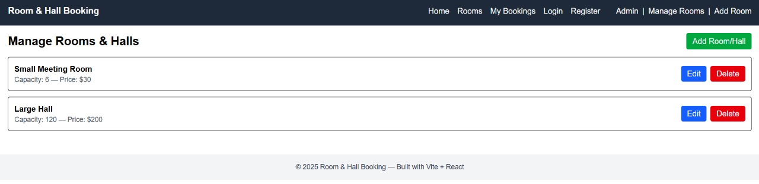

4-

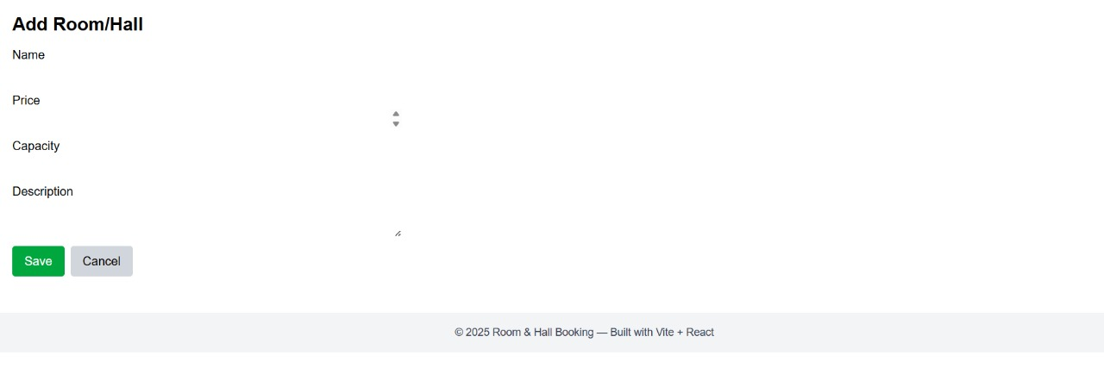
5-
